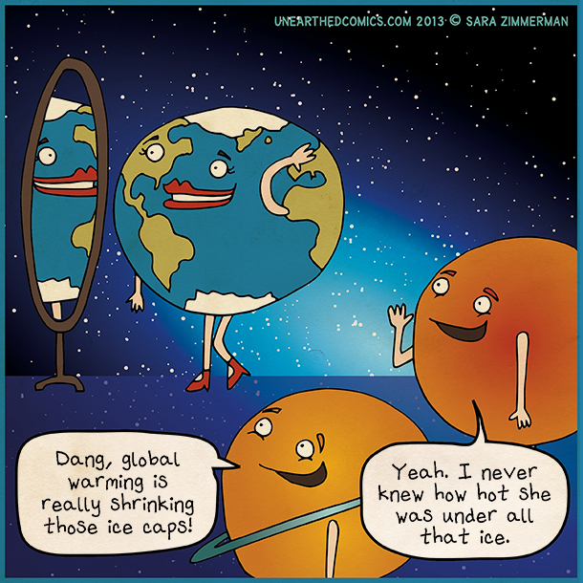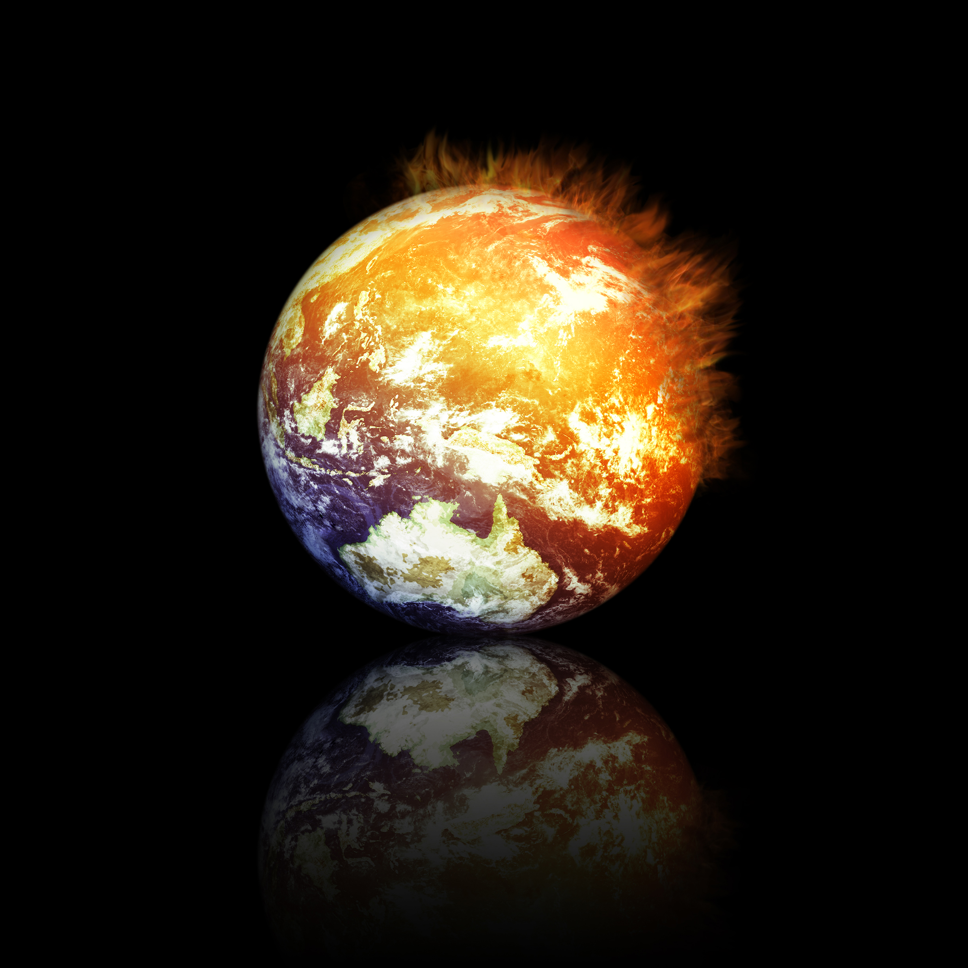

Humans say if carbon dioxide is the cause of global warming than why don’t we all stop breathing.

WARNING!!! All life will end in about 10-20 years. The air will be full of carbon dioxide, lands will be flooded, and mountains will slide into the oceans. Many people believe that humans are the blame for this terrible disaster. There are various scientists that have tried to warn us about our doom but we clearly don’t listen. How can we humans truly be so selfish? There are some who say that global warming is a natural trend. The earth just heats up and cools down on its own. Some say that the real culprit is the sun with all its increased activity.

Global Warming

A Serious Problem

February 21, 2014

# We’re Burning Up!!!!!

Nullam aliquet neque nec ante. Donec fermentum libero. Suspendisse rutrum nunc vel velit. Sed id libero sit amet odio eleifend malesuada. Quisque erat. Mauris lacinia, odio a laoreet lobortis, leo nisi ultrices quam, adipiscing ultricies mi lorem at leo.

Technology is not the problem. I’m sure we will do just fine without heat in the winter and air conditioning in the summer. In the winter we can just huddle together and in the summer we can brainstorm ways to make effective fans. Some people believe that global warming isn’t a problem at all. As the earth continues to heat up, we won’t have to use electricity to warm our houses in the wintertime. As carbon dioxide levels increase, plant growth will also increase. . So, what can we do to help with global warming? The answer is idyllic, give up electricity.